Implementing TCP SACK Conservative Loss Recovery Algorithm within a NDN Consumer

Shuo Yang

1. Design

- Consumer uses packet timeout as signal of congestion;
- Consumer reacts to one packet loss event per RTT (to handle a burst of packet loss);
- Consumer takes one RTT sample per RTT;
- Consumer uses TCP's AIMD scheme to adjust congestion window size;

2. Algorithm

Parameters:
- m_highData: the highest segment number of the Data packet the consumer has received so far;
- m_highInterest: the highest segment number of the Interests the consumer has sent so far;
- m_recPoint: the value of m_highInterest when a packet loss event occurred. It remains fixed until the next packet loss event happens;
- m_cwnd: congestion window size (unit: segment), initial value: 0;
- m_ssthresh: slow start threshold, initial value: 200;
Acked
Sent but not acked
To be sent
m_highData
Time out occurred
m_highInterest
m_recPoint
m_recPoint = 0
Algorithm description:
- Initially, m_highData, m_highInterest and m_recPoint all set to 0;
- A packet loss event happens when m_highData > m_recPoint;
- When a timeout occurred, if m_highData > m_recPoint, this timeout would be considered a packet loss event, consumer should update m_recPoint with the value of m_highInterest, then adjust congestion window size accordingly (ssthresh = cwnd/2, cwnd = 1); otherwise the timeout wouldn't be considered as a packet loss event and consumer doesn't adjust window size;
- the value of m_highData will be updated each time a Data packet was received; the value of m_highInterest will updated each time an Interest packet was sent;

In the above figure, initially, m_recPoint = 0. When the time out happened at the segment represented by the red circle, since m_highData > m_recPoint, it's considered a packet loss,
so m_recPoint = m_highInterest, and consumer won't react to all the timeouts of the segments in the blue area until the condition m_highData > m_recPoint is true again. Therefor consumer only reacts to at most one packet loss per RTT.

Pseudo code:
Function OnData (data, segmentNo)
If m_highData < segmentNo then
m_highData = segmentNo;
End if

If m_cwnd < m_ssthreshold then
m_cwnd = m_cwnd + 1;
Else
m_cwnd = m_cwnd + 1 / m_cwnd;
End if

SchedulePackets();
Function OnTimeout ()
If m_highData > m_recPoint then
m_recPoint = m_highInterest;
m_ssthreshold = m_cwnd / 2;
m_cwnd = m_ssthreshold;
BackoffRto();
End if

SchedulePackets();

3. Implementation

We updated chunks application of ndn-tools repository with the congestion control algorithm mentioned above. The current version of chunks application uses a fixed window size and a “backoff and retry” strategy to deal with packet loss. Regarding to how chunks application works, please refer to “how-chunks-works.pdf” for details.

Without touching other modules, we mainly modified pipeline-interest module with the following changes:
- discard the use of data-fetcher module for Interest transmission, pipeline-interest directly schedules and sends Interests by itself;
- original pipeline-interest module uses NDN's own timeout mechanism (Interest lifetime expiration) to detect timeout, the modified version replies on RTT/RTO estimation as used by TCP.
- An internal class SegmentInfo is used to wrap up a sent-but-not-acknowledged segment's related information. It includes: Pending Interest ID (used to remove a timed out Interest from face), state, RTO (used for timeout detection) and time it was sent (used to calculate RTT) for that segment.
- A key data structure is a C++ std::map that maps segment number to its SegmentInfo object.
std::map<uint64_t, shared_ptr<SegmentInfo>> m_segmentInfoMap;
- an event is scheduled every 10ms (configurable) to check timed out segments. It works by scanning the m_segmentInfoMap, for each sent-but-not-acknowledged segment, calculate how long has passed since it was sent out, if greater than the RTO value stored in SegmentInfo object associated with that segment, time out that segment.

Added modules and features:
- added a rtt-estimator module which implements a mean-deviation RTT estimator as elaborated in RFC6298;
- if -v (verbose) option is on, a brief performance summary will be printed out on the stderr after downloading finishes;
- added a new command line option -s (keep stats) to output statistics to files after downloading finishes;

State diagram for congestion control:

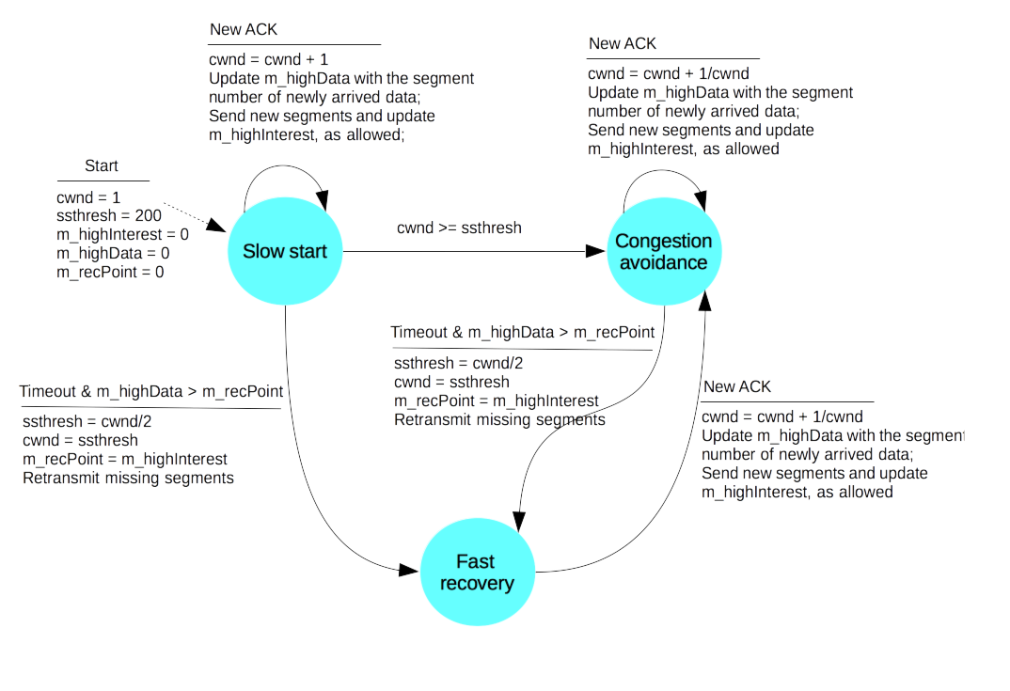

State diagram for segment:

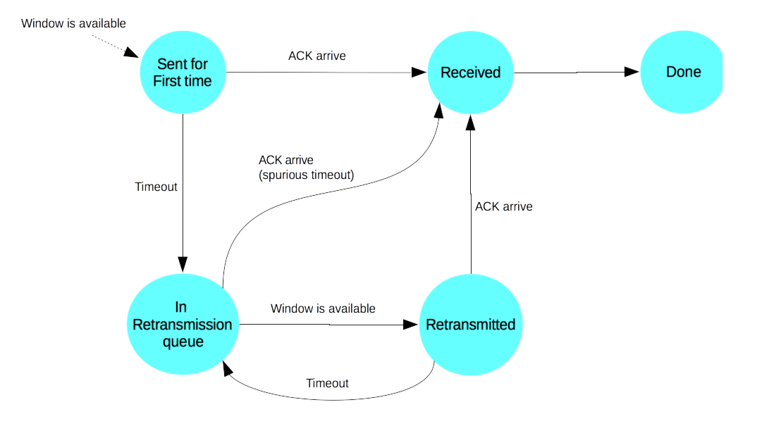

4. Experimentation

Experiment environment: Minindn
Size of the file being transferred: 10MB
Topology: linear and dumbbell

linear topology (bottleneck link: Router1 --- Router2):

5Mbps (max queue size = 32)
Consumer
Router1
Router2
Producer
10Mbps
10Mbps

Traffic: consumer downloads file from producer
Minindn configuration for linear topology (linear.conf):

[nodes]
consumer1: _
router1: _
router2: _
producer1: _
[links]
consumer1:router1 delay=10ms bw=10
router1:router2 delay=10ms bw=5 max_queue_size=32
router2:producer1 delay=10ms bw=10

dumbbell topology (bottleneck link: Router1 --- Router2):

Consumer1
Consumer2
Router1
Router2
Producer2
Producer1
5Mbps (max queue size = 32)
10Mbps
10Mbps

10Mbps
10Mbps

Traffic: cross traffic (consumer1 downloads file from producer1 and consumer2 downloads file from producer2).
Minindn configuration for dumbbell topology (dumbbell.conf):

[nodes]
consumer1: _
router1: _
producer1: _
consumer2: _
router2: _
producer2: _
[links]
consumer1:router1 delay=10ms bw=10
router1:router2 delay=10ms bw=5 max_queue_size=32
router2:producer1 delay=10ms bw=10
consumer2:router1 delay=10ms bw=10
router2:producer2 delay=10ms bw=10

Minindn script for running the experiment (ndnchunk_experiment.py): see attached.

Command for running the experiment:

mini-ndn$ sudo ./install.sh -i
mini-ndn$ sudo minindn --experiment=ndnchunk ./ndn_utils/topologies/linear.conf
mini-ndn$ sudo minindn --experiment=ndnchunk ./ndn_utils/topologies/dumbbell.conf

5. Results analysis and comparison

Performance Metrics:
- Download time: total time it takes to download the file
- Effective throughput:
(number of data received * size of data packet (including header overhead)) / (download time)
- packet loss rate:
number of packet loss bursts happened / total number of packets received

Plots:
- congestion window size changes over time
- RTT samples taken over time
- RTT measured for each segment and its caculated RTO

Comparison:
- Design #0:
  - Fixed cwnd with optimal value (32 for linear topology, 16 for dumbbell topology)
- Design #1:
  - AIMD scheme
  - Consumer reacts to multiple packet losses per RTT
  - Consumer takes multiple RTT samples per RTT
- Design #2:
  - AIMD scheme
  - Consumer reacts to one packet loss event per RTT
  - Consumer takes multiple RTT samples per RTT
- Design #3: our design

Results:

linear topology:

Design #0:

Time (s) | Throughput (kbps) | Timeout percentage
23.8 | 4986 | 0%
23.8 | 4984 | 0%
23.9 | 4969 | 0%
Design #1:

Time (s) | Throughput (kbps) | Timeout percentage
39 | 3038 | 1.3%
36.9 | 3213 | 1.1%
34 | 3497 | 0.85%

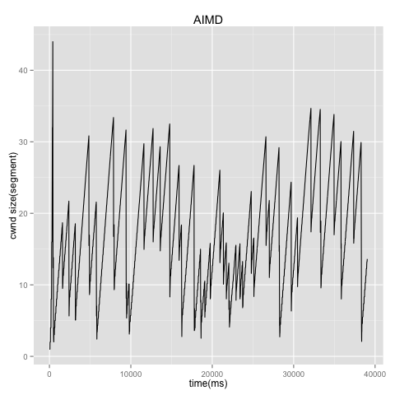
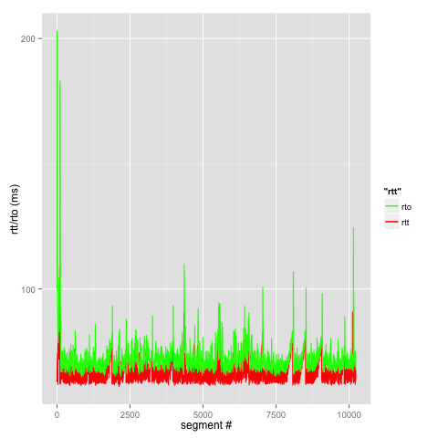
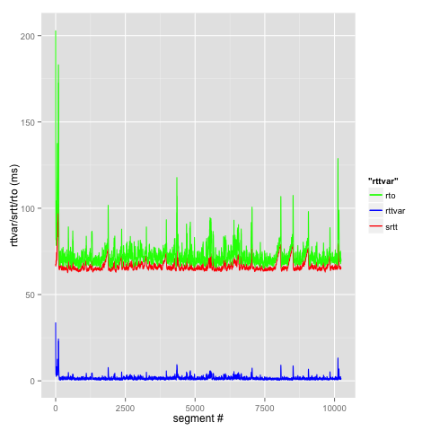

Design #2:

Time (s) | Throughput (kbps) | Timeout percentage
29.8 | 3983 | 0.65%
30.4 | 3900 | 0.4%
31.1 | 3808 | 0.4%
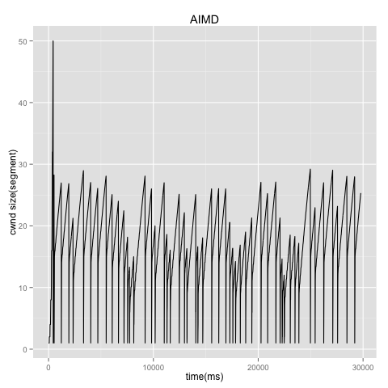
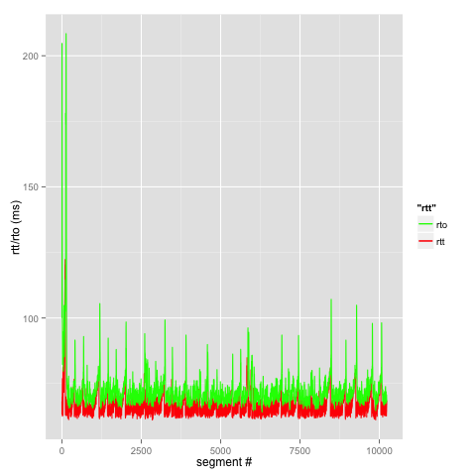
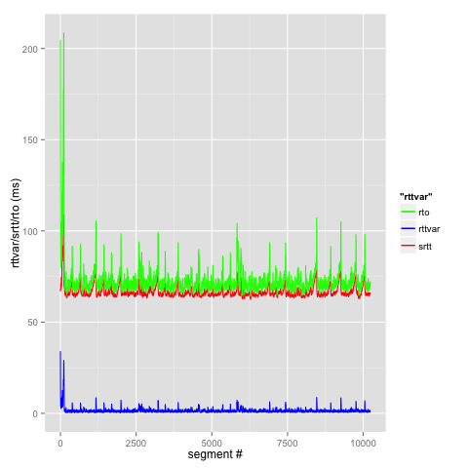

Design #3:

Time (s) | Throughput (kbps) | Timeout percentage
24.5 | 4844 | 0.1%
25 | 4745 | 0.14%
25 | 4748 | 0.13%

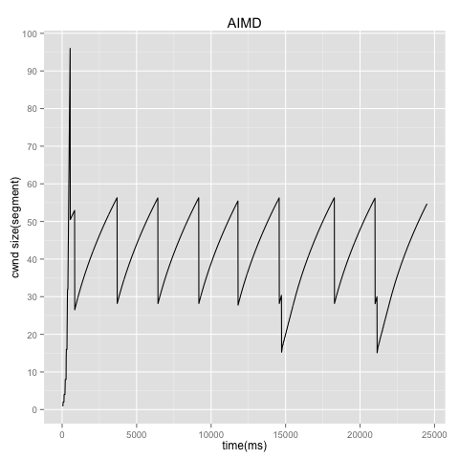
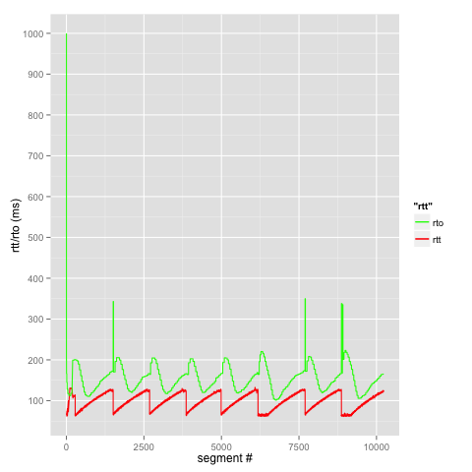
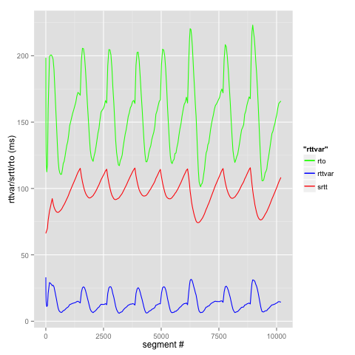

dumbbell topology:

Design #0:

Consumer1 |  |  | Consumer2
Time (s) | Throughput (kbps) | Timeout percentage | Time (s) | Throughput (kbps) | Timeout percentage
47.5 | 2496 | 0 | 47.5 | 2496 | 0
47.8 | 2483 | 0 | 47.8 | 2481 | 0
47.7 | 2487 | 0 | 47.7 | 2487 | 0

Design #1:

Consumer1 |  |  | Consumer2
Time (s) | Throughput (kbps) | Timeout percentage | Time (s) | Throughput (kbps) | Timeout percentage
59 | 2009 | 2.3% | 56.7 | 2094 | 2.7%
57 | 2082 | 3.4% | 58.5 | 2027 | 3.2%
54.3 | 2183 | 2.2% | 48.4 | 2452 | 2.4%

Plots for Consumer1:

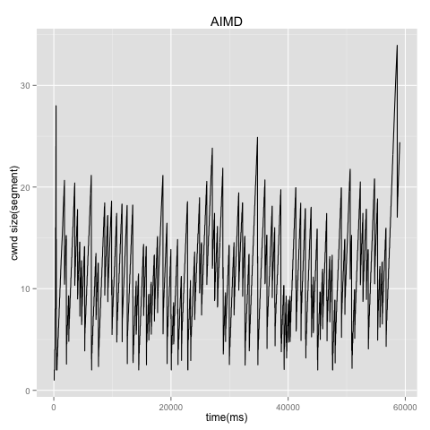
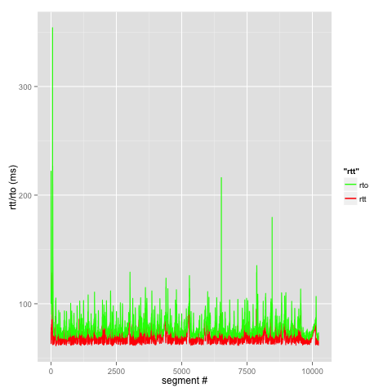
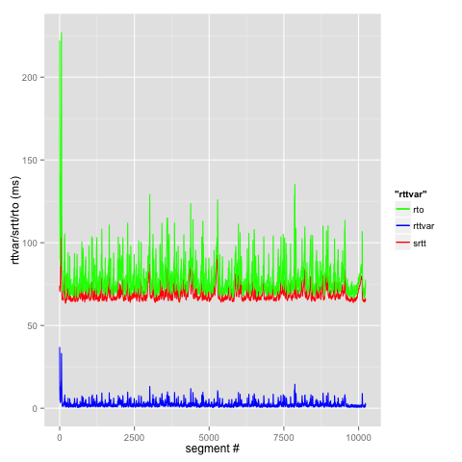
Plots for Consumer2:
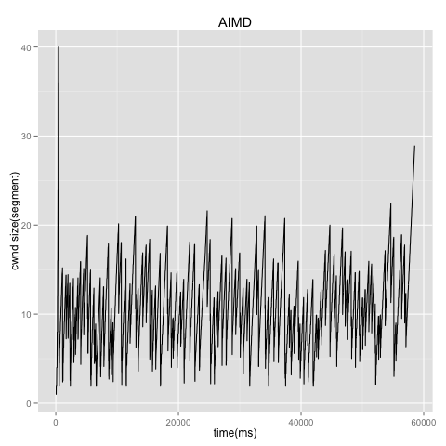
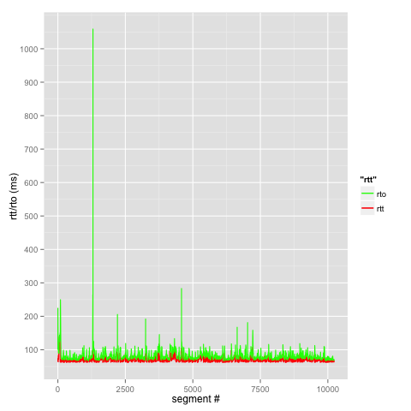
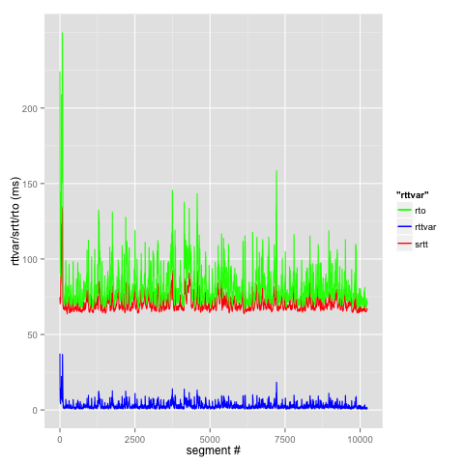

Design #2:

Consumer1 |  |  | Consumer2
Time (s) | Throughput (kbps) | Timeout percentage | Time (s) | Throughput (kbps) | Timeout percentage
51.8 | 2292 | 0.93% | 50.7 | 2342 | 0.9%
52.9 | 2243 | 1.1% | 52.9 | 2242 | 1.1%
53.3 | 2227 | 1.6% | 51.5 | 2301 | 1.2%

Plots for Consumer1:

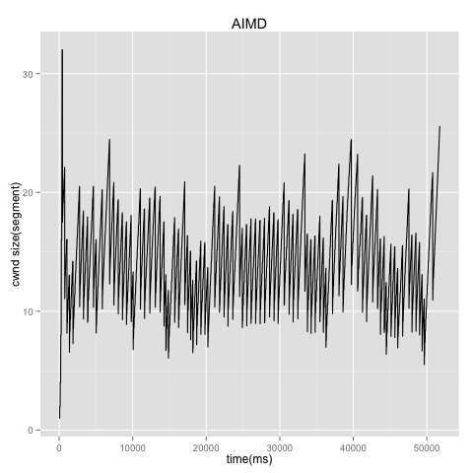
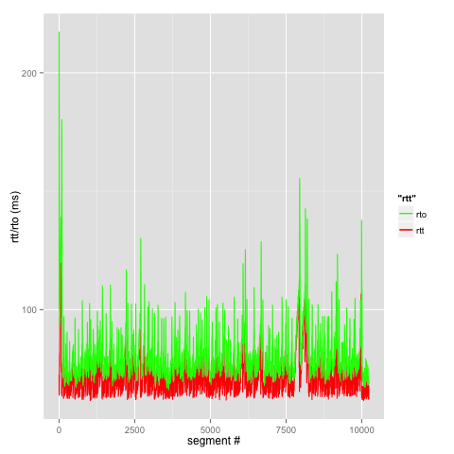
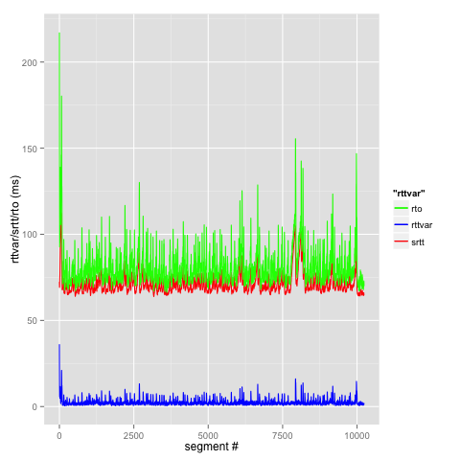
Plots for Consumer2:

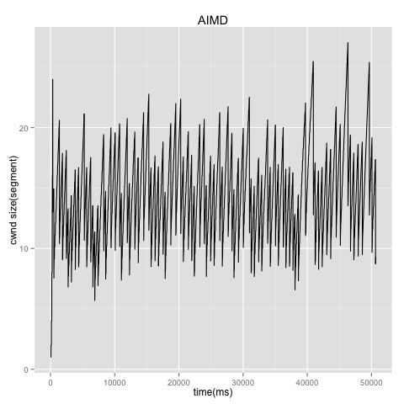
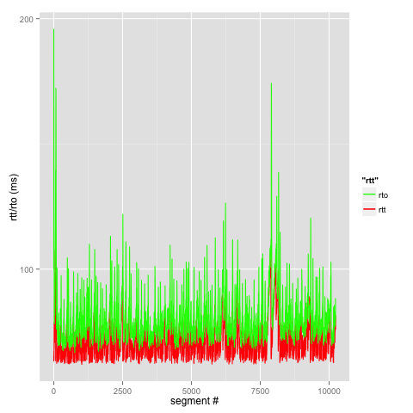
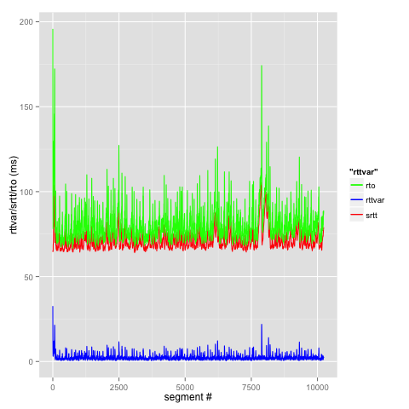
Design #3:

Consumer1 |  |  | Consumer2
Time (s) | Throughput (kbps) | Timeout percentage | Time (s) | Throughput (kbps) | Timeout percentage
48.2 | 2462 | 0.34% | 46.4 | 2555 | 0.31%
47.7 | 2488 | 0.33% | 48 | 2471 | 0.34%
48.1 | 2467 | 0.34% | 45.4 | 2616 | 0.29%

Plots for Consumer1:

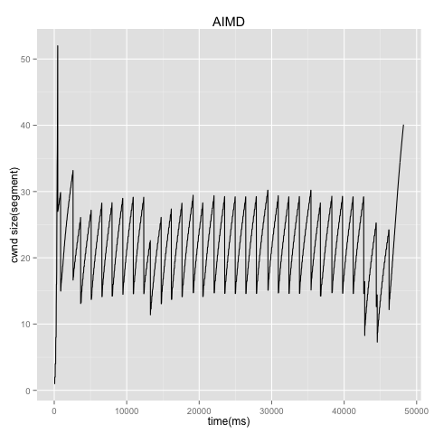
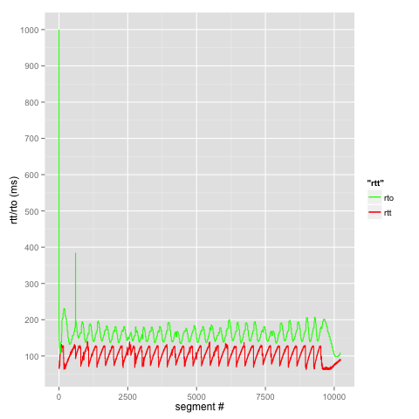
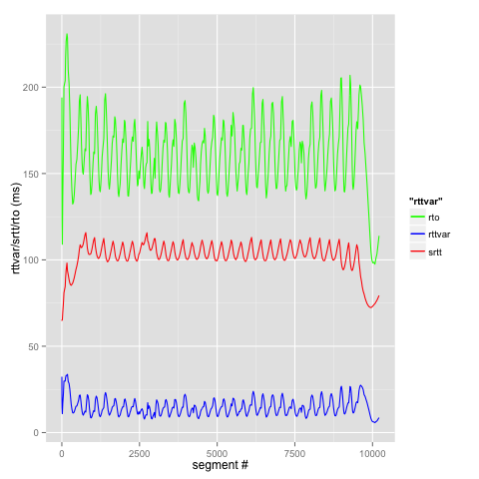
Plots for Consumer2:

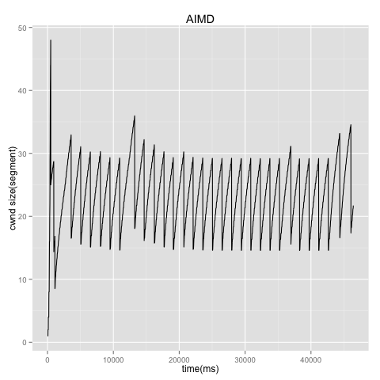
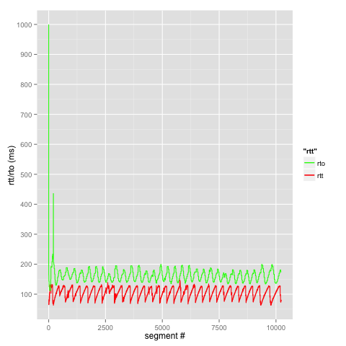
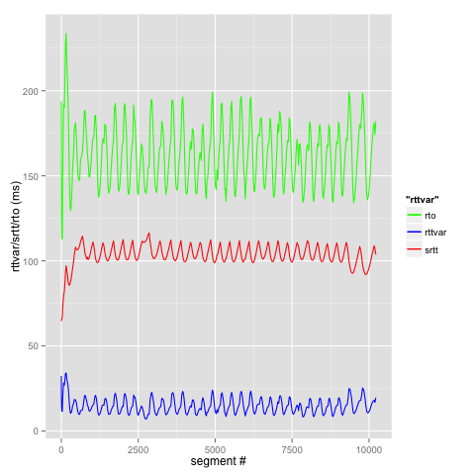
Observations & Analysis:

- Design #0 sets a baseline for performance comparison, other designs can perform no better than it.
- Consumer needs to wait for RTO to expire to be aware of congestion.
- In Design #1, due to multiple packet losses within one RTT, the connection cannot reach the equilibrium state, which causes the packet conservation to fail.
- Design #2 has problem of making full use of available window size, most likely due to inadequate estimation of RTT and RTO values.
- Design #3 yields performance very close to that of Design #0, most time it can make full use of congestion window and dynamically react to congestion condition in time. The overhead, comparing to Design #0 would be the process of adjusting window size, especially linear increase of window size. It also shows that taking one sample per RTT yields better RTT & RTO estimation.
- For the dumbbell topology, two consumers can share the bottleneck link bandwidth evenly most of time.

